APPENDICES

A1: Household Survey Questionnaire

Var: today
Date of the interview

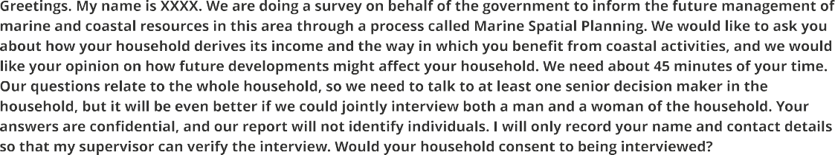



Var: PAPARTICIPANTSSTATEMENT
If the participant consent or not. Values are OK or NO






A1Gender_householdhead
Gender of the household head
Var: A2Age_householdhead
Age of the household head












Var: A3Marital_Status
Marital status of the household head
Var: A4Education_Householdhead
Level of education of the household head


Adults (age 60+)

Adults (age 18-59)

Youth (age 13-17)

Children (age 0-12)

Var: A5_1Adultsage60
How many adults with 60 y/o or more living in the household.
Var: A5_2Adultsage1859
How many adults between 18-59 y/o living in the household.
Var: A5_3Youthage1317
How many young persons between 13-17 y/o living in the household.
Var: A5_4Childrenage012
How many children between 0-12 y/o living in the household.

To which religious group does this household belong?
Q None/Atheist or Agnostic Q Roman Catholic Christianity Q Islam
Q Zionist
Q Protestant Christianity
Q Traditional
Q Other
Q Don't know

Var: A6religion (removed from data)

How long have you been resident in this village/ area (in years)?

Var: A7residence
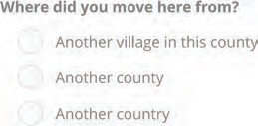

Var: A8movedfrom

RESIDENCE AND NEIGHBOURHOOD CHARACTERISTICS

What are the main house's walls made of?

Q Mud
Q Mud bricks - local/homemade
Q Don't know

Var: B1Housewall_material
Q Thatch/leaf/reed/palm/ bamboo
Q Commercial bricks
Q Cement blocks
Q Other

What is the roof made of?
Q Thatch/leaf/reed/palm/ bamboo
Q Corrugated iron
Q Mud
Q Cement/concrete
Q Other
Q Don't know

Var: B2Roof_material

What is the household's main source of energy for cooking and lighting?
0 Firewood
0 Batteries
0 Solar panel
0 Public electricity grid
0 Oil/Paraffin/kerosene
0 Candles
0 Other
0 Don't know

Var: B3_1Mainsource_cookingenergy
Var: B3_2Mainsource_lightingenergy
What is the household's main source of water?

River Well or borehole Tap connected to public
water system

Var: B4Mainsource_water

Does this household own any of the following?
Rainwater storage
Other Don't know

Bicycle Motorbike
Car Phone
Radio
TV Fridge Mobile phone

Canoe or rowing boat
Dhow (sailboat)
Motorboat
Tuktuk
Minibus Truck House

farmland Don't know

Vars: B5Doesthishouseholdownanyo; B5Bicycle, B5motorbike, B5car, B5phone, B5radio, B5tv, B5fridge, B5mobilephone, B5canoe, B5dhow, B5motorboat, B5tuktuk, B5minibus, B5truck, B5house, B5farmland, B5Dont_know

About how long would it take to get from your home to the nearest school if you walked?
Q 10 minutes or less
Q 11-20 minutes
Q 21-30 minutes
Q More than 30 minutes
Q Don't know

Var: B6Distance_nearestSchool

About how long would it take to get from your home to the nearest market if you walked?
Q 10 minutes or less
Q 11-20 minutes
Q 21-30 minutes
Q More than 30 minutes
Q Don't know

Var: B7Distance_nearestMarket

About how long would it take to get from your home to the nearest clinic by motorized transport?
Q 10 minutes or less
Q 11-20 minutes
Q 21-30 minutes
Q More than 30 minutes
Q Don't know
Var: B8Distance_nearestClinic

EMPLOYMENT AND INCOME

Has anyone in this household earned income from formal or casual employment here in this area in the last 3 years?
Q Yes Q No Q Don't know

Var: C1Earned_Income_yesno

Please divide these 20 beans to show how much the following contribute to your household's monetary income in a typical month.

Employment
Please count the number of beans and enter here:

Var: C2_1Employment

Own fishing or other livelihood activities involving coastal and marine resources or coastal tourists
Please count the number of beans and enter here:

Var: C2_2Ownfishing

Own farming or livelihood activities involving upland resources
Please count the number of beans and enter here:
Var: C2_3Ownfarming

Pensions and welfare
Please count the number of beans and enter here:
Var: C2_4Pensionsandwelfare

Remittances
Please count the number of beans and enter here:

Var: C2_5Remittances

LIVELIHOOD ACTIVITIES AND INCOME

» Fishing by boat

I am going to ask separately about fishing by boat and fishing on the shore. Let's start with boat-based fishing. How many men in this household have regularly gone fishing out to sea (by motorised boat, dhow or canoe) in the last 12 months?

Var: D11Numbermen_Fishing_offshore

And how many women?

Var: D12Numberwomen_Fishing_offshore

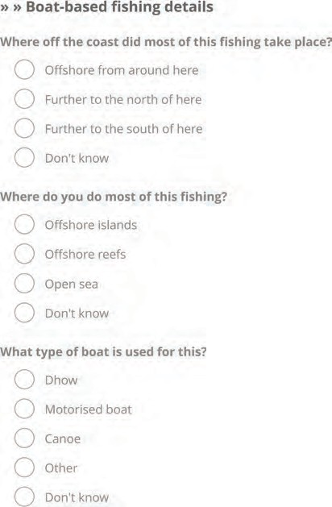
Vars: D13Fishingarea_offshore, D13_1FishingAroundHere, D13_2FishingNorth, D13_3FishingSouth

Var: D14Most_offshorearea_Fished
Var: D15Boat_Type

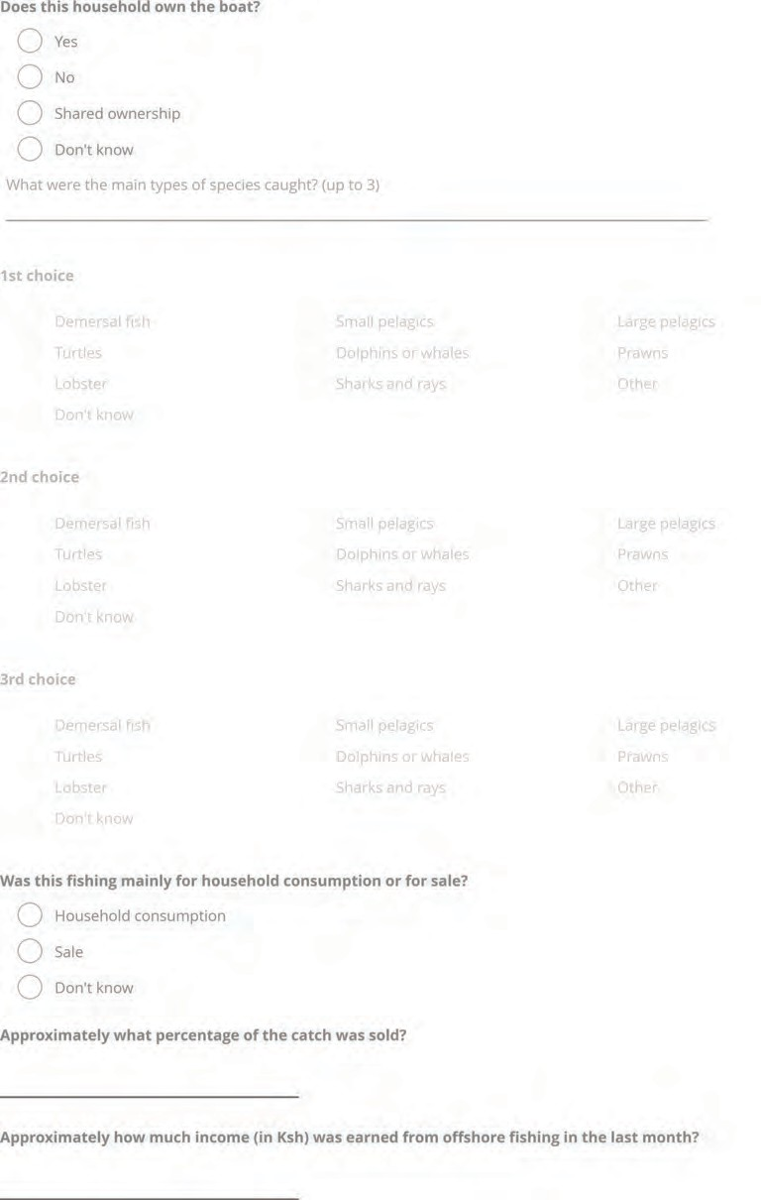

Var: D16Householdboat_Ownership
Var: D17_1firstcatch_offshore (1st choice)
Var: D17_2secondcatch_offshore (2nd choice)
Var: D17_3thirdcatch_offshore (3rd choice)
Var: D18offshore_fish_sale
Var: D19proportion_offshorefish_sold
Var: D110income_offshore_lastmonth

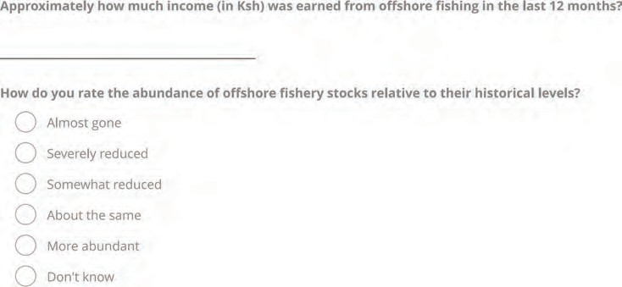

Var: D111income_offshore_lastyear
Var: D20Howdoyouratetheabunda

Var: D21Numbermen_Fishing_onshore
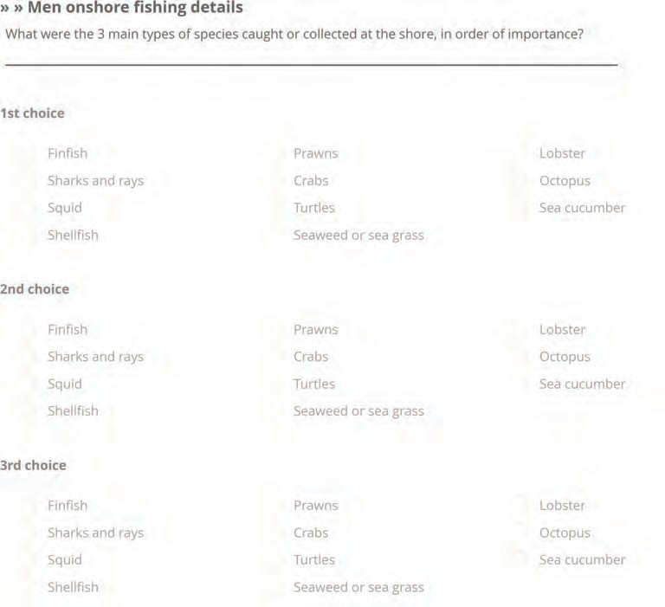

Var: D22_1M_firstcatch_onshore (1st choice)
Var: D22_2M_secondcatch_onshore (2nd choice)
Var: D22_3M_thirdcatch_onshore (3rd choice)

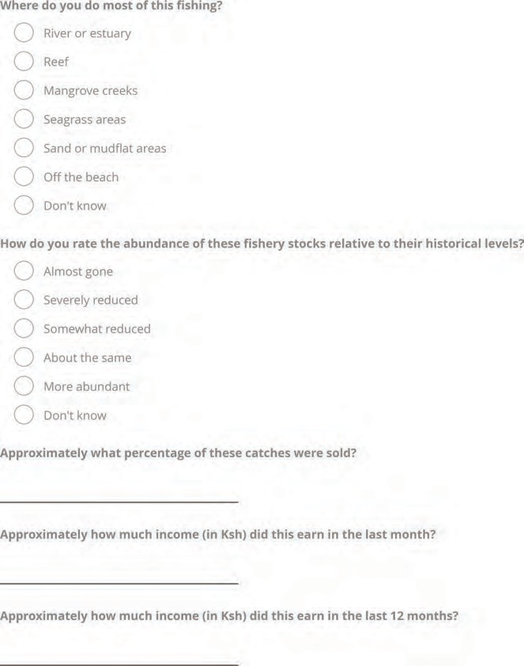

Var: D23M_Fishingarea_onshore
Var: D24Howdoyouratetheabundan (abundance rating)
Var: D25M_percentage_sold
Var: D26M_income_onshore_lastmonth
Var: D27M_income_onshore_lastyear

Var: D31Numberwomen_Fishing_onshore
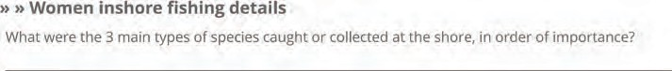

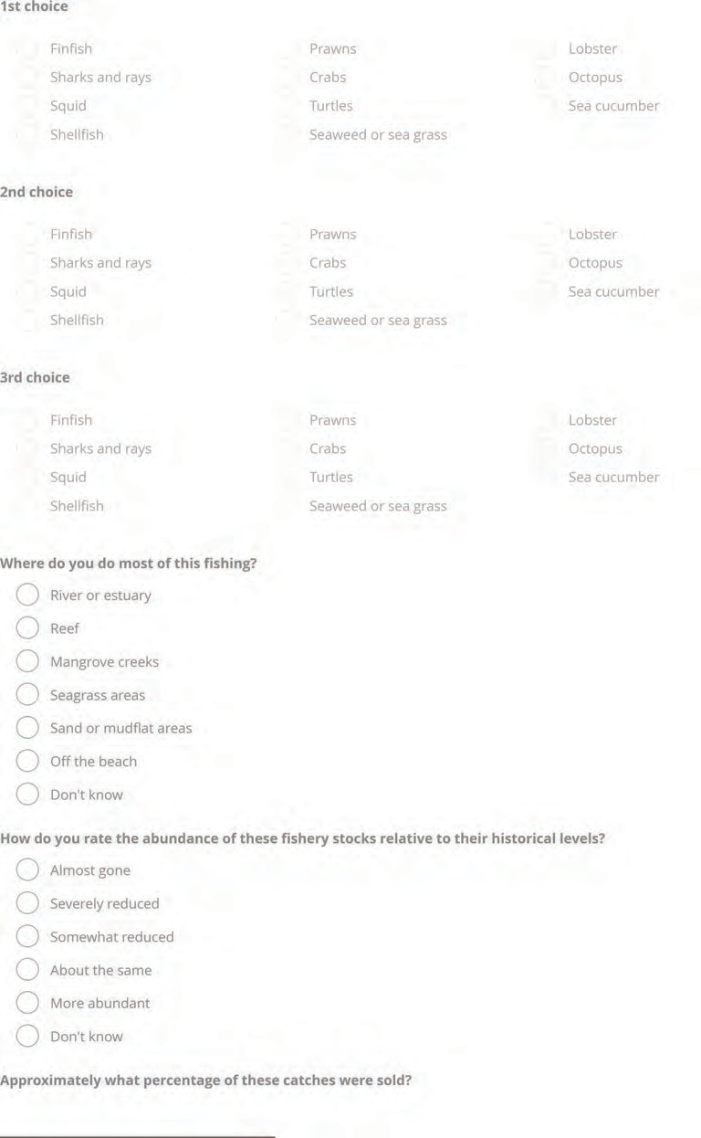

Var: D32_1W_firstcatch_onshore
Var: D32_2W_secondcatch_onshore
Var: D32_3W_thirdcatch_onshore
Var: D33W_Fishingarea_onshore
Var: D34Howdoyouratetheabundan (abundance)
Var: D35W_percentage_sold

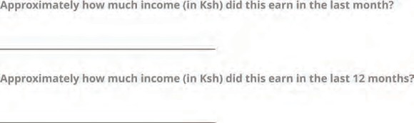
Var: D36W_income_onshore_lastmonth
Var: D37W_income_onshore_lastyear

» Fish processing and trading

Have any members of the household been regularly involved in buying fish or other sealife from fishers to process and sell?
Q Yes
Q No
Q Don't know
Var: D41Fishtrading

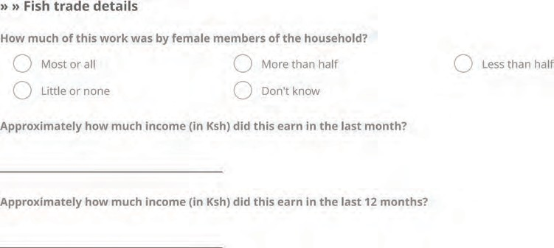

Var: Howmuchofthisworkwasbyfem
Var: D43income_fishtrading_lastmonth
Var: D44income_fishtrading_lastyear

» Salt

Has anyone in this household been regularly involved in salt making in the past 12 months?
Q Yes Q No Q Don'tknow
Var: D51Salt

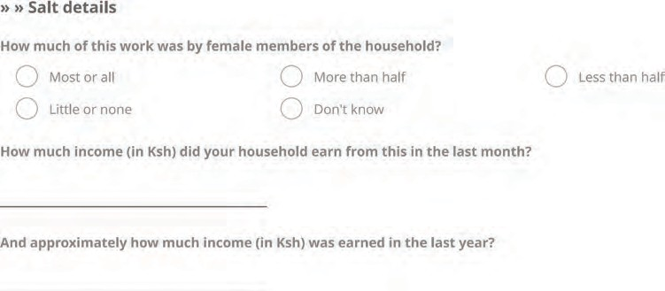
Var: D52Howmuchofthisworkwasb
Var: D53income_salt_lastmonth
Var: D54income_salt_lastyear





Var: D61Mariculture
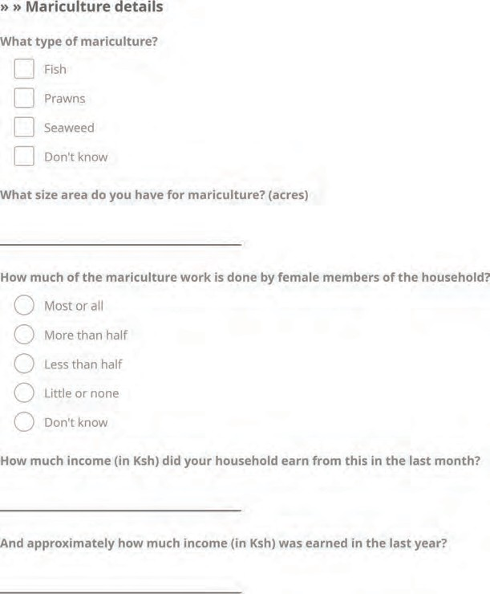
Var: D62Type_mariculture
Var: D62Fish_mariculture
Var: D62Prawns_mariculture
Var: D62Seaweed_mariculture
Var: D62Dontknow_mariculture
Var: D63Mariculture_landsize
Var: Howmuchofthemariculturework
Var: D65income_mariculture_lastmonth
Var: D66income_mariculture_lastyear





Var: D71Tourism

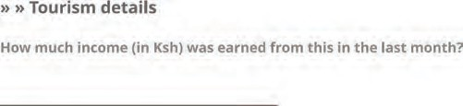
Var: D72income_tourism_lastmonth

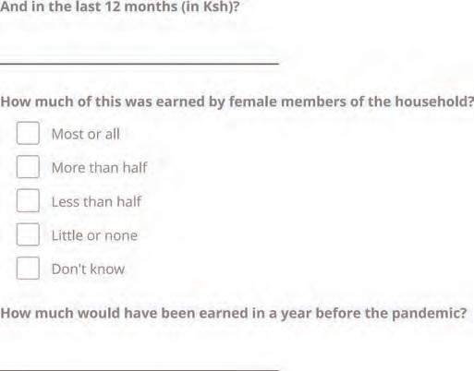
Var: D73income_tourism_lastyear
Var: D74W_income_tourism
Var: D75income_tourism_prepandemic




Var: D81Timber
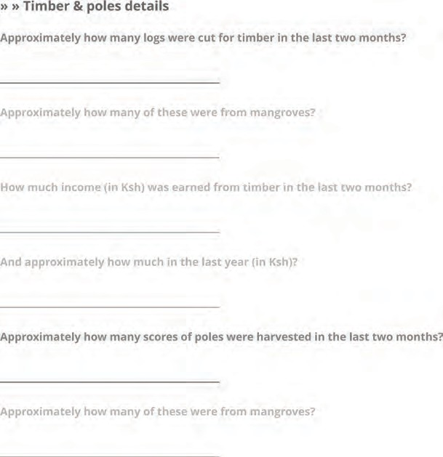
Var: D82Number_of_logs
Var: D83Mangrove_timber
Var: D84income_timber_last2months
Var: D85income_timber_lastyear

Var: D86number_poles_harvested
Var: D87mangrove_poles

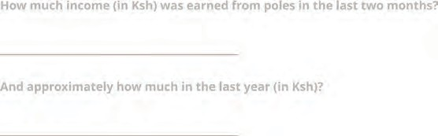

Var: D88income_poles_lastmonth
Var: D89income_poles_lastyear




Var: D91Charcoal

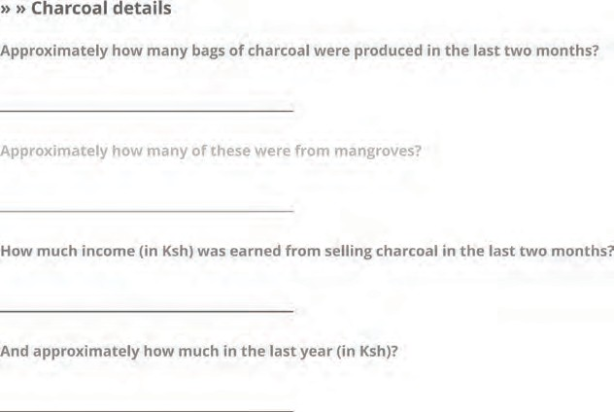
Var: D92Charcoalbags_last2months
Var: D93charcoal_mangroves
Var: D94income_charcoal_last2month
Var: D95income_charcoal_lastyear





Var: D101Collect_firewood

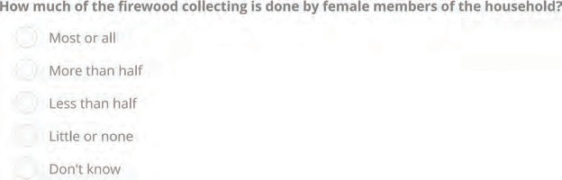
Var: D102Howmuchofthefirewoodc

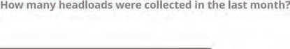
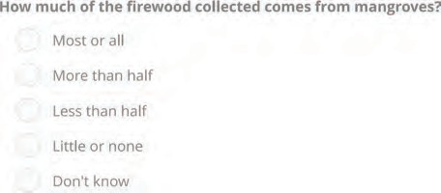
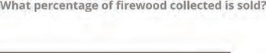




Var: D103firewood_headloads_collected
Var: D104firewood_frommangroves
Var: D105firewood_proportion_sold
Var: D111Wildfood

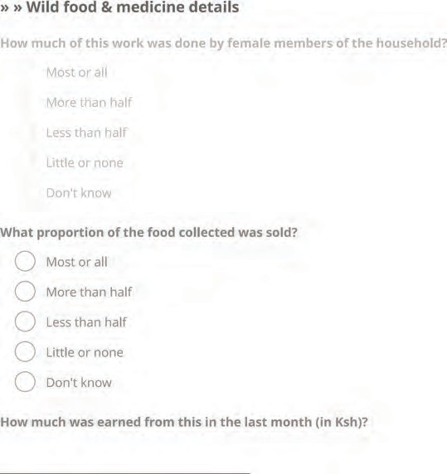

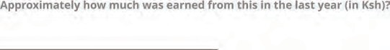

Var: D112Howmuchofthisworkwas
Var: D113Whatproportionofthefoo
Var: D114income_wildfood_lastmonth
Var: D115income_wildfood_lastyear





Var: D121Hunting

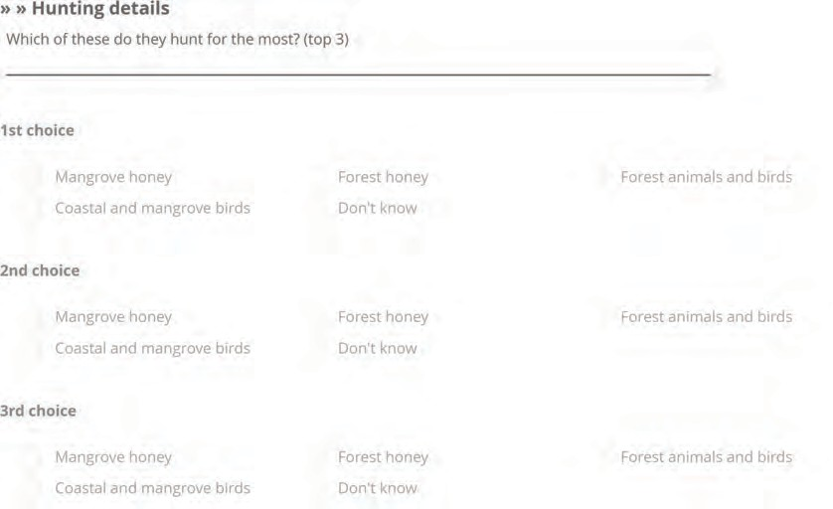
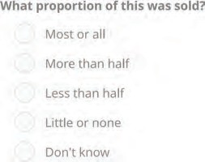
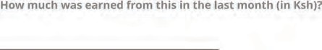
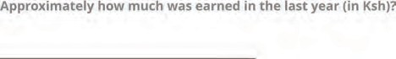

Var: D1221firstmost_hunted
Var: D1222secondmost_hunted
Var: D1223thirdmost_hunted
Var: D123hunt_proportion_sold
Var: D124income_hunt_lastmonth
Var: D125income_hunt_lastyear





Var: D131harvested_plant

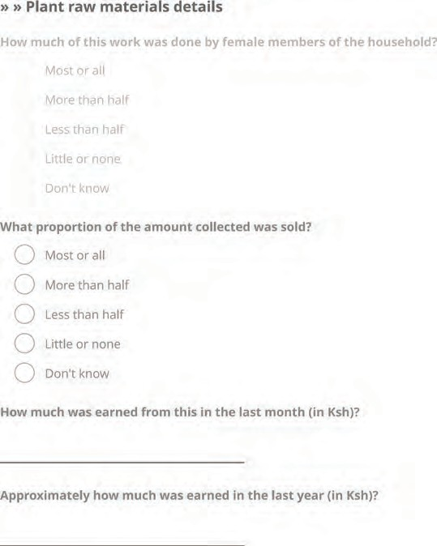




Var: D132Howmuchofthisworkwas
Var: D133Whatproportionoftheamo
Var: D134income_plant_lastmonth
Var: D135income_plant_lastyear
Var: D141Mining

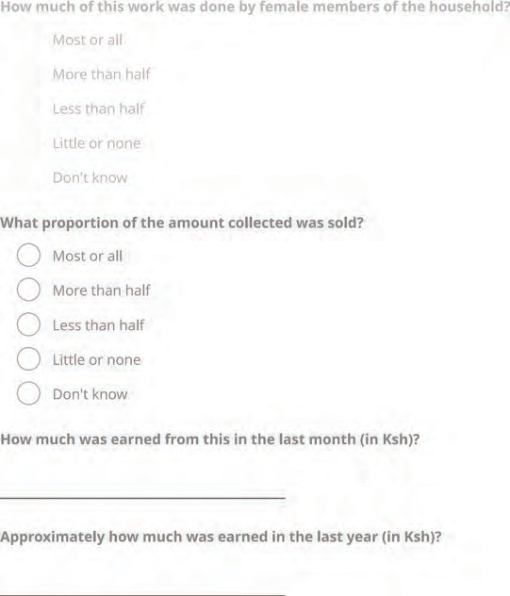

Var: D142W_mining
Var: D143proportion_sold
Var: D144income_mining_lastmonth
Var: D145income_mining_lastyear




Var: D151Sale

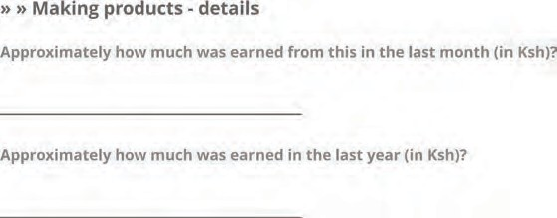

Var: D152income_sale_lastmonth
Var: D153income_sale_lastyear

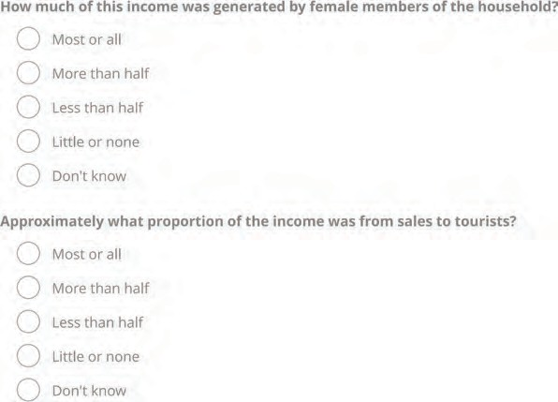

Var: D154Howmuchofthisincomewa
Var: D155Approximatelywhatproport





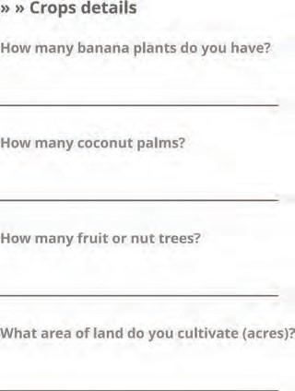

Var: D161crop_farming
Var: D162banana_stems
Var: D163coconut_palms
Var: D164fruits_nuts
Var: D165Crop_area_cultivated

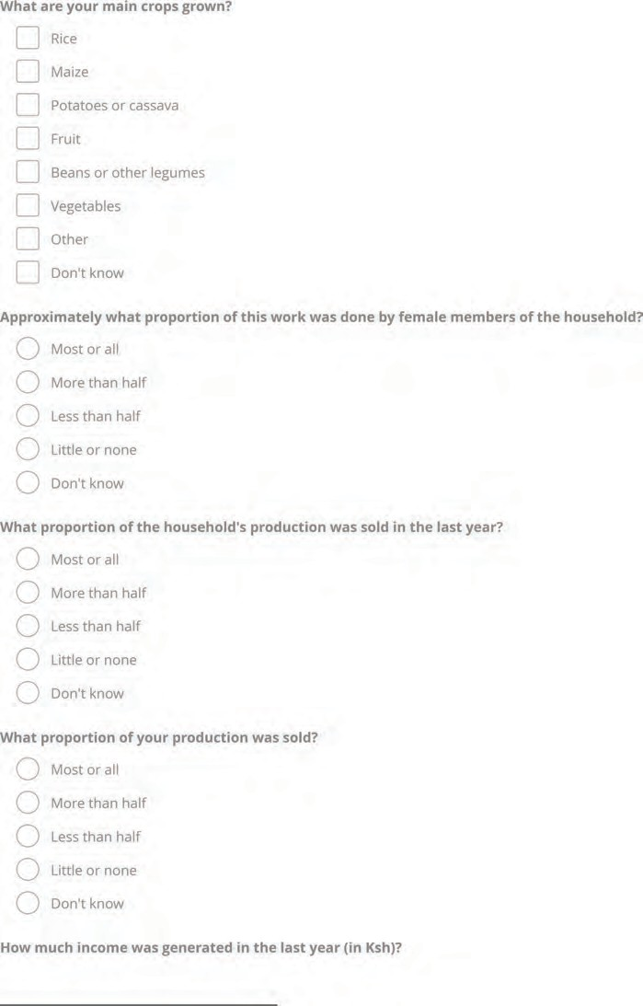

Var: D166rice_farming
Var: D166maize_farming
Var: D166potatoes_cassava_farming
Var: D166fruit_farming
Var: D166beans_legumes_farming
Var: D166vegetables_farming
Var: D166othercrops_farming
Var: D166dontknow
Var: crops_females
Var: D168AnnualProportion_crop_sold
Var: Whatproportion_sold
Var: D169income_crop_lastyear

Do you keep poultry?
Q Yes
Q No
Q Don'tknow
Does this household have any other livestock?
Q Yes
Q No
Q Don'tknow

Var: D171Poultry
Var: D172livestock_farming

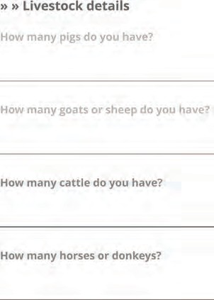
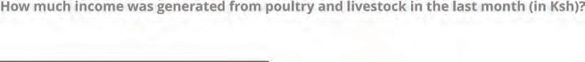
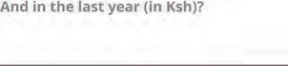

Var: D173Number_pigs
Var: D174Number_sheep_goats
Var: D175Number_cattle
Var: D176Number_horse_donkey
Var: D177monthlyincome_livestock
Var: D178annualincome_livestock

SECURITY AND VOICE
Please rate the following on a scale from 1 = strongly disagree to 7 = strongly agree:
1 2 |  |  | 3 | 4 | 5 | 6 | 7
0 | 0 |  | 0 | 0 | 0 | 0 | 0
0 | 0 |  | 0 | 0 | 0 | 0 | 0
0 | 0 |  | 0 | 0 | 0 | 0 | 0
 |  | 2 | 3 | 4 | 5 | 6 | 7

My family functions well for all members. My family's day to day interactions are
peaceful.
Family members accommodate each
other.
Please rate the following on a scale from 1 = strongly disagree to 7 = strongly agree:

Our community is harmonious.
0 | 0 | 0 | 0 | 0 | 0 | 0
0 | 0 | 0 | 0 | 0 | 0 | 0
0 | 0 | 0 | 0 | 0 | 0 | 0
0 | 0 | 0 | 0 | 0 | 0 | 0
0 | 0 | 0 | 0 | 0 | 0 | 0
0 | 0 | 0 | 0 | 0 | 0 | 0

Life in this area is very peaceful.

There is conflict over access to resources in this area.
Local government officials are trustworthy.
Households are able to voice their concerns about the use and management of our coastal and marine areas through organisational structures.
I feel that our concerns about marine and coastal management are heard.

Var: E1Myfamilyfunctionswell
Var: E2Myfamilysinteractionspeaceful
Var: E3Familymembersaccommodate
Var: E4Ourcommunityisharmonious
Var: E5Lifeispeaceful
Var: E6Thereisconflictoveraccess
Var: E7Localgovernmenttrustworthy
Var: E8Voiceconcerns
Var: E9Concernsareheard

Are any men in the household part of any community organisations? Please select:
Q Church, mosque or other local religious group
Q Fishing association or co-operative Q Farming association or co-operative Q Business association or cooperative Q Political organisation
Q Neighbourhood security group
Q Environmental or conservation association
Q Educational, developmental or social welfare association
Q Don't know

Var: E10 (1 = Yes; 0 = No)
Var: E10ReligiousGroup_M
Var: E10Fishingcooperative_M
Var: E10Farmingcooperative_M
Var: E10Businesscooperative_M
Var: E10PoliticalOrganisation_M
Var: E10NeighbourhoodSecurity_M
Var: E10EnvironmentalConservation_M
Var: E10EducationalAssociation_M
Var: E10DontKnow_M

Are any women in the household part of any community organisations? Please select:
Q Church, mosque or other local religious group
Q Fishing association or co-operative Q Farming association or co-operative Q Business association or cooperative Q Political organisation
Q Neighbourhood security group
Q Environmental or conservation association
Q Educational, developmental or social welfare association
Q Don't know

Var: E10ReligiousGroup_W
Var: E10Fishingcooperative_W
Var: E10Farmingcooperative_W
Var: E10Businesscooperative_W
Var: E10PoliticalOrganisation_W
Var: E10NeighbourhoodSecurity_W
Var: E10EnvironmentalConservation_W
Var: E10EducationalAssociation_W
Var: E10DontKnow_W

To what extent are women involved in decision-making in the house, on:

How the household earns an income How the household spends its money Where the household lives
Children's schooling

Seldom or Not at all
0 | 0 | 0 | 0
0 | 0 | 0 | 0
0 | 0 | 0 | 0
0 | 0 | 0 | 0

Sometimes

Often Mostly or
Having children
0 | 0 | 0 | 0
0 | 0 | 0 | 0

Women's occupations and activities

Var: E12Howthehouseholdearnsani
Var: E13Howthehouseholdspendsits
Var: E14Wherethehouseholdlives
Var: E15Childrensschooling
Var: E17Womensoccupationsandacti

Please say how much you agree with the following, based on a scale from 1 = strongly disagree to 7 = strongly agree

The coastal and marine life around here is healthy, diverse and productive.

0 | 0 | 0 | 0 | 0 | 0 | 0
Strongly disagree | Disagree | Somewhat | Neutral | Somewhat agree | Agree | Strongly agree
 |  | disagree
It is important to ensure that inshore fishing areas are not impacted by other developments.
0 | 0 | 0 | 0 | 0 | 0 | 0
Strongly disagree | Disagree | Somewhat | Neutral | Somewhat agree | Agree | Strongly agree
 |  | disagree
There are too many restrictions on fishing in this area, like closed areas, closed seasons or permits.
0 | 0 | 0 | 0 | 0 | 0 | 0
Strongly disagree | Disagree | Somewhat | Neutral | Somewhat agree | Agree | Strongly agree
 |  | disagree
Fishing regulations in this area are well enforced.
0 | 0 | 0 | 0 | 0 | 0 | 0
Strongly disagree | Disagree | Somewhat | Neutral | Somewhat agree | Agree | Strongly agree
 |  | disagree
Anyone should be able to fish or harvest resources in this area.
0 | 0 | 0 | 0 | 0 | 0 | 0
Strongly disagree | Disagree | Somewhat | Neutral | Somewhat agree | Agree | Strongly agree
 |  | disagree
Ecotourism is an important source of income in this area.
0 | 0 | 0 | 0 | 0 | 0 | 0
Strongly disagree | Disagree | Somewhat | Neutral | Somewhat agree | Agree | Strongly agree
 |  | disagree
Small-scale fishing is threatening the marine life in the area.
0 | 0 | 0 | 0 | 0 | 0 | 0
Strongly disagree | Disagree | Somewhat | Neutral | Somewhat agree | Agree | Strongly agree
 |  | disagree
An increase in industrial activities along this coast will increase the risk to our marine life.
0 | 0 | 0 | 0 | 0 | 0 | 0
Strongly disagree | Disagree | Somewhat | Neutral | Somewhat agree | Agree | Strongly agree
 |  | disagree

Our household supports marine wildlife conservation.

0 | 0 | 0 | 0 | 0 | 0 | 0
Strongly disagree | Disagree | Somewhat | Neutral | Somewhat agree | Agree | Strongly agree
 |  | disagree
There is a good balance between protection and use of marine resources in this area.
0 | 0 | 0 | 0 | 0 | 0 | 0
Strongly disagree | Disagree | Somewhat | Neutral | Somewhat agree | Agree | Strongly agree
 |  | disagree
If the government gets more taxes from big business, it will deliver better services in our area.
0 | 0 | 0 | 0 | 0 | 0 | 0
Strongly disagree | Disagree | Somewhat | Neutral | Somewhat agree | Agree | Strongly agree
 |  | disagree

How do you rate the overall level of government services in your local area, including the quality of public roads and recreational spaces?
0 | 0 | 0 | 0 | 0 | 0 | 0 | 0
Very poor | Poor | Below average | Average | Good | Very good | Excellent | Don't know

Var: F1Healthy_marinelife
Var: F2Protect_inshore_fishing
Var: F3Toomanyfishingrestrictions
Var: F4Wellenforcedfishingregulations
Var: F5Anyoneshouldbeabletofish
Var: F6Ecotourismisanimportant
Var: F7Smallscalefishingthreatened
Var: F8Industrialactivitiesrisk
Var: F9Supportconservation
Var: F10Balance_use_protection
Var: F11Taxes_better_services
Var: F12Howdoyouratetheoverall

Which of these marine sectors is a key source of formal employment in your community?
0 Coastal tourism
0 Oil and gas
0 Fish processing
0 Shipbuilding
0 Marine fisheries
0 Ports
0 Aquaculture
0 Transport
0 Marine renewables
0 Desalination
0 Coastal protection
0 Marine biotechnology
0 Don't know
Var: F13Importance_marine_sectors

How would you rate the general availability of marine sector formal jobs for men, women and youth in your community? (on a scale of 1 (not available) to 7 (abundant))

For men

0 0 0

0 0 0 0

1 2 3 4 5 6 7

Var: F14Marine_sector_job_men

For women

0 0 0 0 0 0 0
2 3 4 5 6 7

For youth

0 0 0 0 0 0 0
2 3 4 5 6 7

Var: F15Marine_sector_job_women
Var: F16Marine_sector_job_youth

Which types of development in this area would provide this household with the best opportunities for income? Rank in order of preference

1st choice
Q Coastal tourism
0 Shipbuilding Q Aquaculture Q Desalination Q Don't know

2nd choice
Q Coastal tourism
0 Shipbuilding Q Aquaculture Q Desalination Q Don'tknow

3rd choice
Q Coastal tourism
0 Shipbuilding Q Aquaculture Q Desalination Q Don't know

0 Oil and gas 0 Fish processing
0 Marine fisheries 0 Ports
0 Transport 0 Marine renewables
0 Coastal protection 0 Marine biotechnology

0 Oil and gas 0 Fish processing
0 Marine fisheries 0 Ports
0 Transport 0 Marine renewables
0 Coastal protection 0 Marine biotechnology

0 Oil and gas 0 Fish processing
0 Marine fisheries 0 Ports
0 Transport 0 Marine renewables
0 Coastal protection 0 Marine biotechnology

Var: F17Development_1stChoice
Var: F17Development_2ndChoice
Var: F17Development_3rdChoice

Would you say that your community is fairly represented in blue sector formal jobs in this area?
Q Yes
0 No
Q Don't know

Would you vote for a situation where job opportunities are increased if it meant loss of access to small scale fishing?
0 Probably
0 Probably not
0 Don't know
And if it only meant loss of access to the marine resources that are collected from the shore at low tide?
0 Probably
Q Probably not
Q Don't know

Var: F18Community_bluesectorjobs
Var: F19Ind_increase_OffshoreLoss
Var: F20Ind_increase_OnshoreLoss

CHOICE QUESTION
Now I would like to ask you about how you feel about potential future development decisions regarding the use of the coastal and marine areas in this county. The government of Kenya is embarking on the process of Marine Spatial Planning. One of the outcomes of this process will be decisions on the zonation of the coastal and ocean areas for different types of uses, and whether and how this might change from what we have today. Decisions will need to be made about what areas to set aside for protection and tourism, for different types offishing or aquaculture, for ports and shipping, or for oil and gas exploitation, or other activities. The government will also need to decide how to find a balance between high value activities that generate jobs and taxes to pay for government services, and the status of natural resources from which households derive material and non-material benefits. Depending on how different types of developments or activities are prioritized for this area, it might affect your household in the following ways. Firstly, household income from formal or casual employment could change. It might go up if the area undergoes development in different sectors, or it could even go down if some activities are moved away from this area. Secondly, it might affect the amount of marine resources that you would have access to in inshore and onshore areas. This could change as a result of changing the area available for fishing and/or the impacts from other sectors. Thirdly, it will also affect the level of protection of coastal and marine ecosystems and wildlife, and the capacity of these systems to generate benefits such as recreation or protection from storms, or helping to reduce climate change. This would be determined by how much area is set aside in reserves, as well as how ecosystems might be impacted by other types of developments. In this exercise I am going to show you the potential outcomes of three possible marine spatial planning scenarios, and then I am going to ask you to choose which one you would vote for if you had the choice. We'll do this four times. Before we start, I need to mention the COVID pandemic. We realise that the world has changed a lot during the COVID pandemic. We'd like you to consider the situation before the pandemic, as being the business as usual situation that we expect to return to in the near future. We are comparing everything against this baseline..

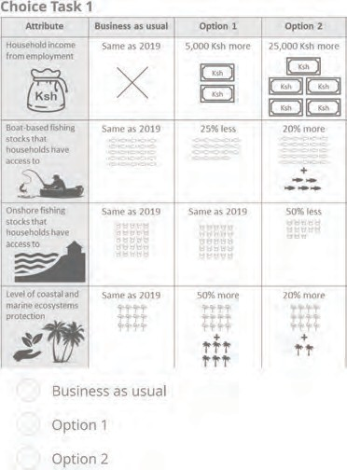

Var: ChoiceTask1

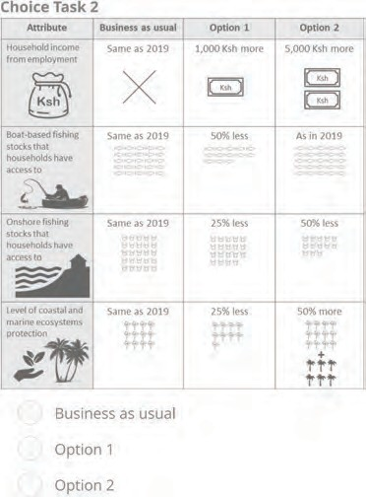

Var: ChoiceTask2

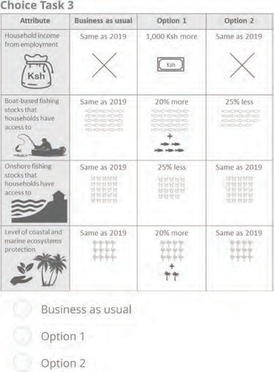

Var: ChoiceTask3
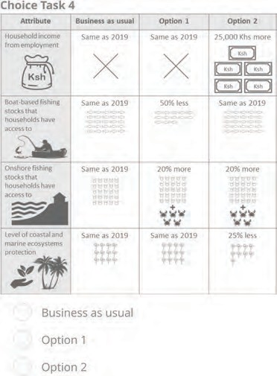
Var: ChoiceTask4

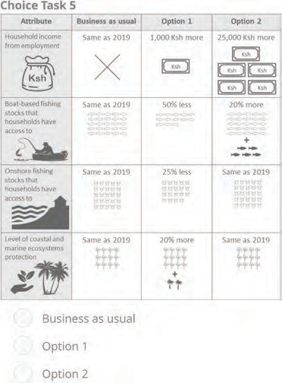
Var: ChoiceTask5
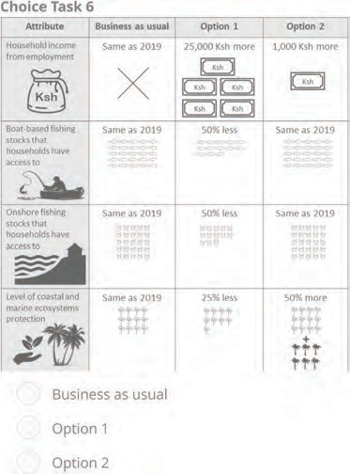
Var: ChoiceTask6

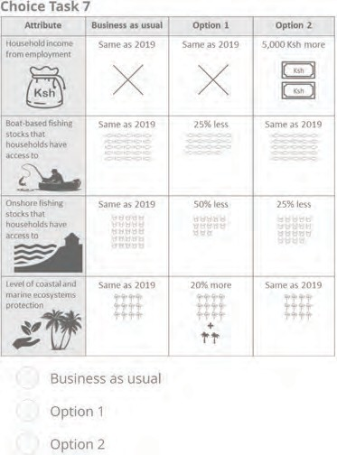
Var: ChoiceTask7
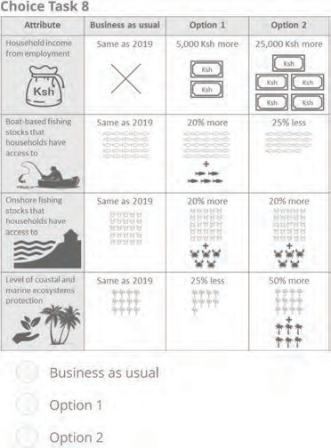

Var: ChoiceTask8

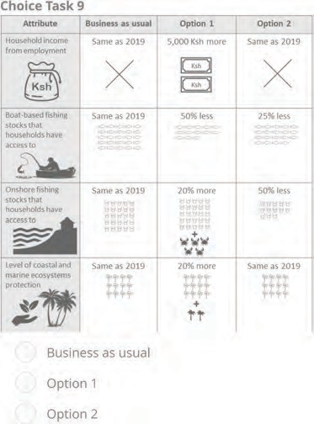
Var: ChoiceTask9
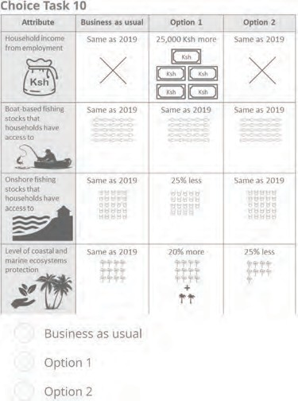

Var: ChoiceTask10

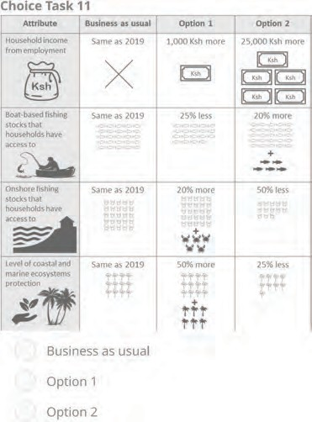
Var: ChoiceTask11

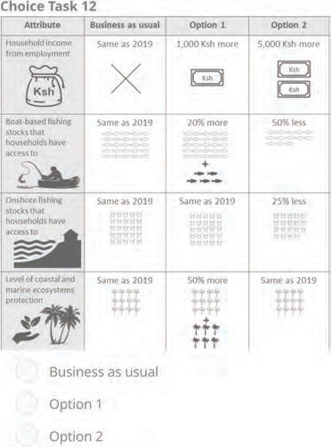
Var: ChoiceTask12

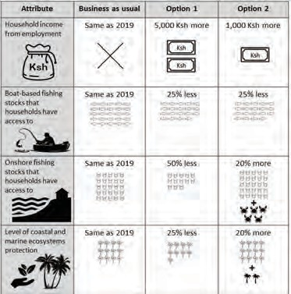






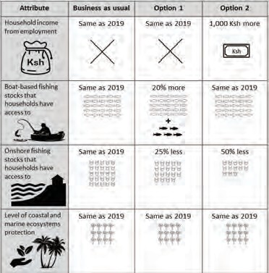

Var: ChoiceTask13
Var: ChoiceTask14

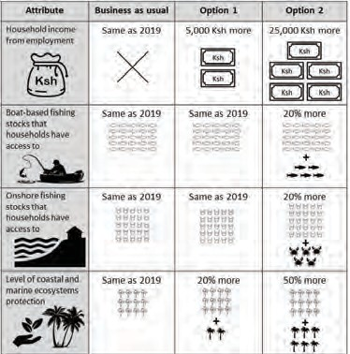






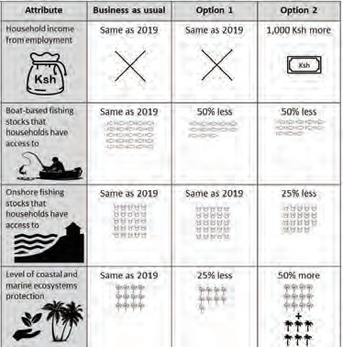

Var: ChoiceTask15
Var: ChoiceTask16

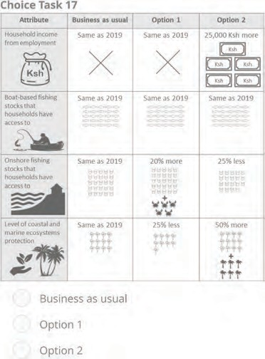
Var: ChoiceTask17

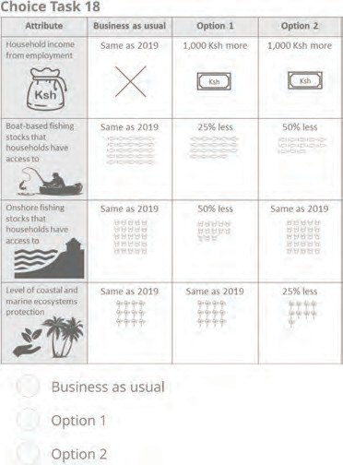
Var: ChoiceTask18

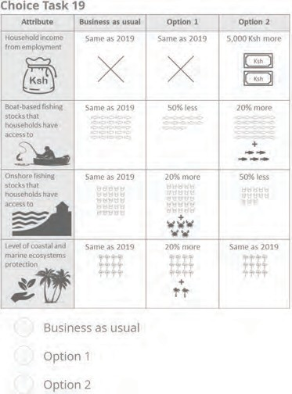
Var: ChoiceTask19
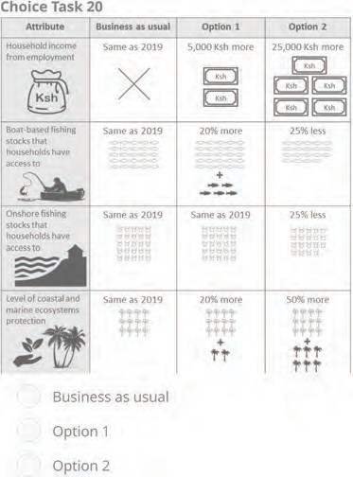

Var: ChoiceTask20

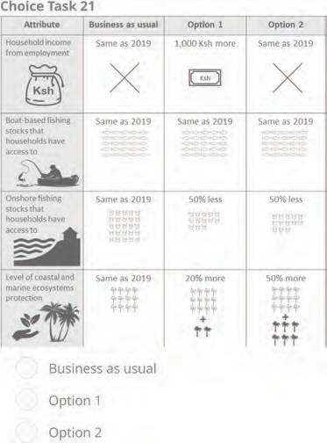
Var: ChoiceTask21

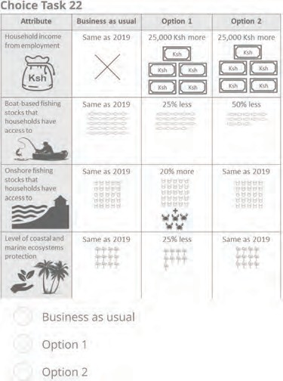
Var: ChoiceTask22

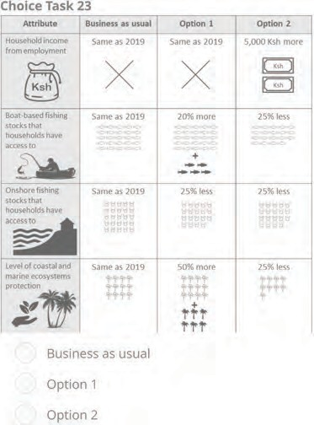
Var: ChoiceTask23
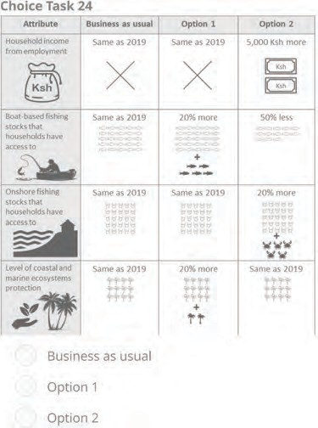
Var: ChoiceTask24

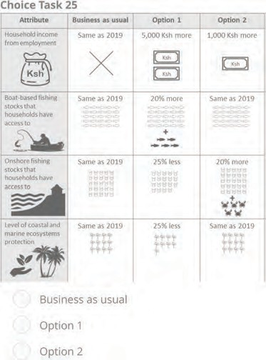

Var: ChoiceTask25
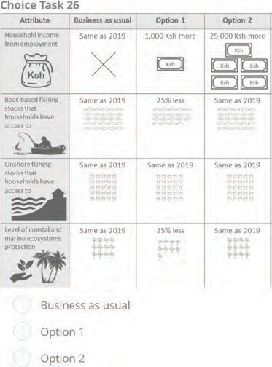
Var: ChoiceTask26

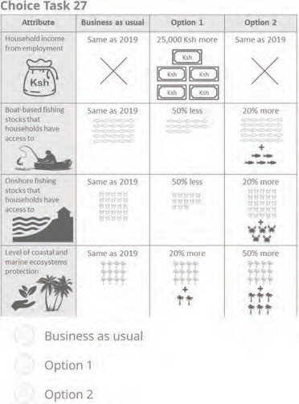
Var: ChoiceTask28
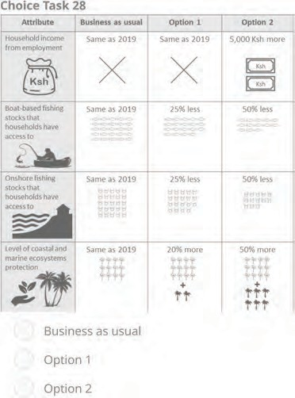
Var: ChoiceTask29

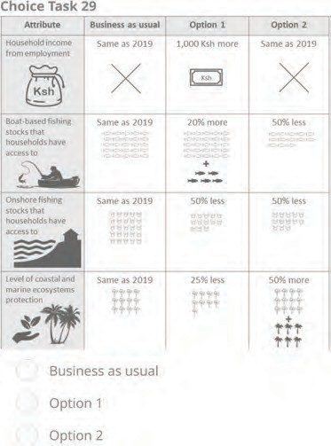
Var: ChoiceTask29
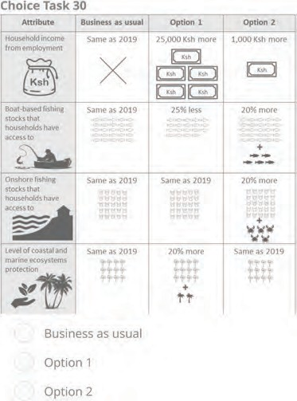

Var: ChoiceTask30

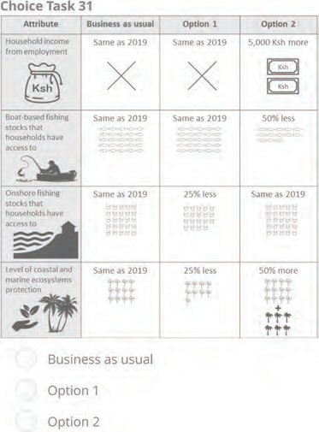
Var: ChoiceTask31
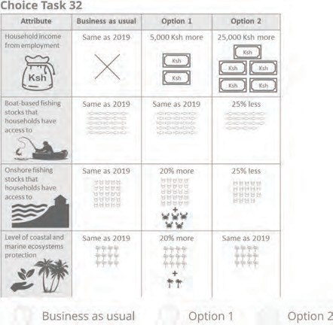




Var: ChoiceTask32
Var: Doyoubelievethatthepotentia

To what extent was this household's income negatively affected by the COVID-19 pandemic?
0 Very little
0 Moderately
0 Greatly
0 Don't know

Var: H1Covid_impact
Did your use of any of the following increase as a result?
0 Boat based fishing
0 Marine resources harvested at the shore
0 Mangrove wood
0 Sand, salt or other mining
0 Bush and forest resources
0 Don't know

Var: H2 (1 = Yes; 0 = No)
Var: H2Fishing
Var: H2MarineResources
Var: H2MangroveWood
Var: H2Mining
Var: H2ForestResources
Var: H2DontKnow
Var: H2Noneoftheabove

That is the end of the interview. Thank you for your time.

INTERVIEW DETAILS

GPS location

latitude (x.y 0)

longitude (x.y 0)

altitude (m)

accuracy (m)

County
Q Kwale
Q Other
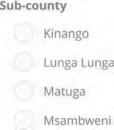
Village name

Who was present
0 An adult male
0 An adult female
Was the female able to express herself freely?
0 No
Q Somewhat
Q Yes
Overall quality of the interview (reliability of information given)
Q Poor
0 OK
Q Good
Understanding of the choice question
Q Poor
Q Good
Any other comments, observations or information to take note of

Var: District
Var: Village
Var: sublocation
Var: WhowaspresentAnadultmale
If there was an adult male present
Var: WhowaspresentAnadultfemale
If there was an adult female present
Var: Wastherespondentabletoexpre
If the respondent was able to express him/herself
Var: Overallqualityoftheinterview
Overall quality of the interview
Var: Understandingofthechoiceques
Understanding of the multiple choice questions

